The Tehsildar,
Tehsildar South,
Amar Niwas Complex, Tankipora, Srinagar, Jammu and Kashmir.

Subject: Application for issuance of Blood Relation Certificate.
Respected Sir/Madam,
Kindly issue blood relation certificate in my name Sheikh Mushtaq Ahmad S/o Sheikh Ghulam Ahmad R/o Clay Model, Barzulla Srinagar having Aadhar card no: 62211862270 as I want to gift my land and house to my daughters namely:
- Ishrat Ara Aadhar No 964970291115
- Nuzhat Ara Aadhar No 678624411115
- Shafquat Ara Aadhar No 475724823155
I shall be highly obliged if you kindly issue the required Blood Relation Certificate at the earliest.
Thanking you,

Yours faithfully,
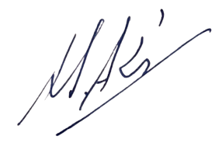

Sheikh Mushtaq Ahmad
Son of Late Sheikh Ghulam Ahmad
Resident: Clay Model (Barzulla), Srinagar
Enclosures:
Photocopy of Aadhaar Cards.

